User Manual for Book Store Application

1. Firstly you need to update database from package manager console.

2. You need to add roles in database. Go to database 🡺 Tables 🡺dbo.AspNetRoles.

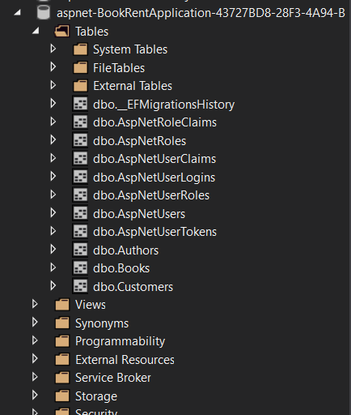

3.Right Click to dbo.AspNetRoles table and click view data.

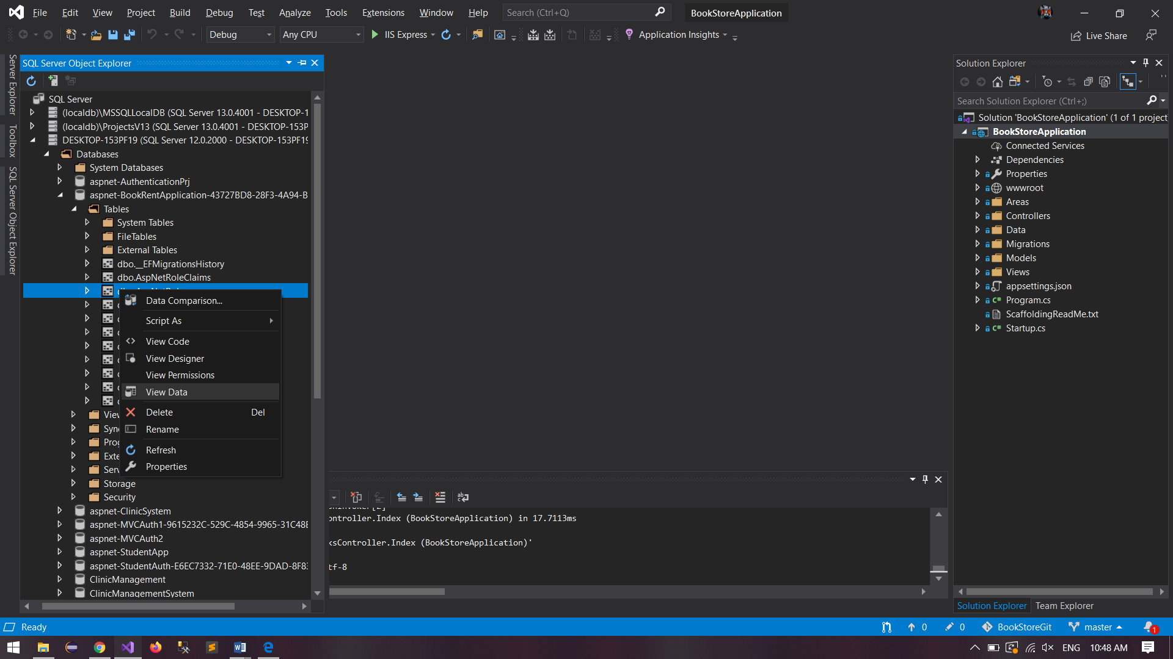

4. Add Id,Name,NormalizedName and save.

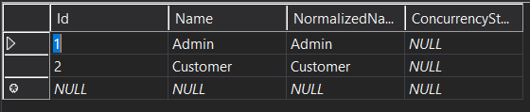

5. Run the application, go to Register page and register.

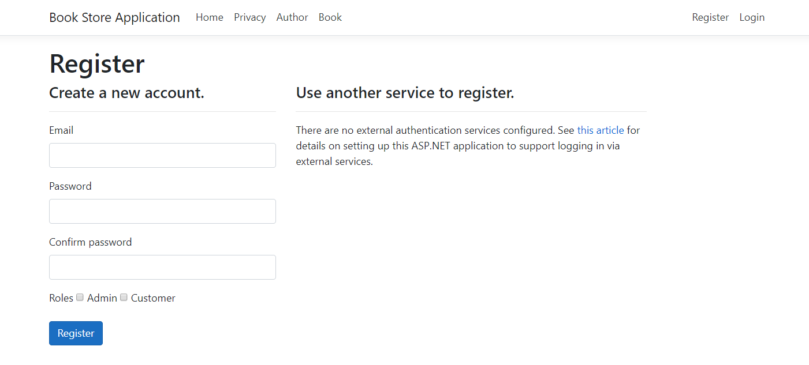

6. Select at least one role for user.

7. If the user role is Admin, the user can create, edit, details and delete the authors and books.

8. If the user role is Customer, the user can only view books.